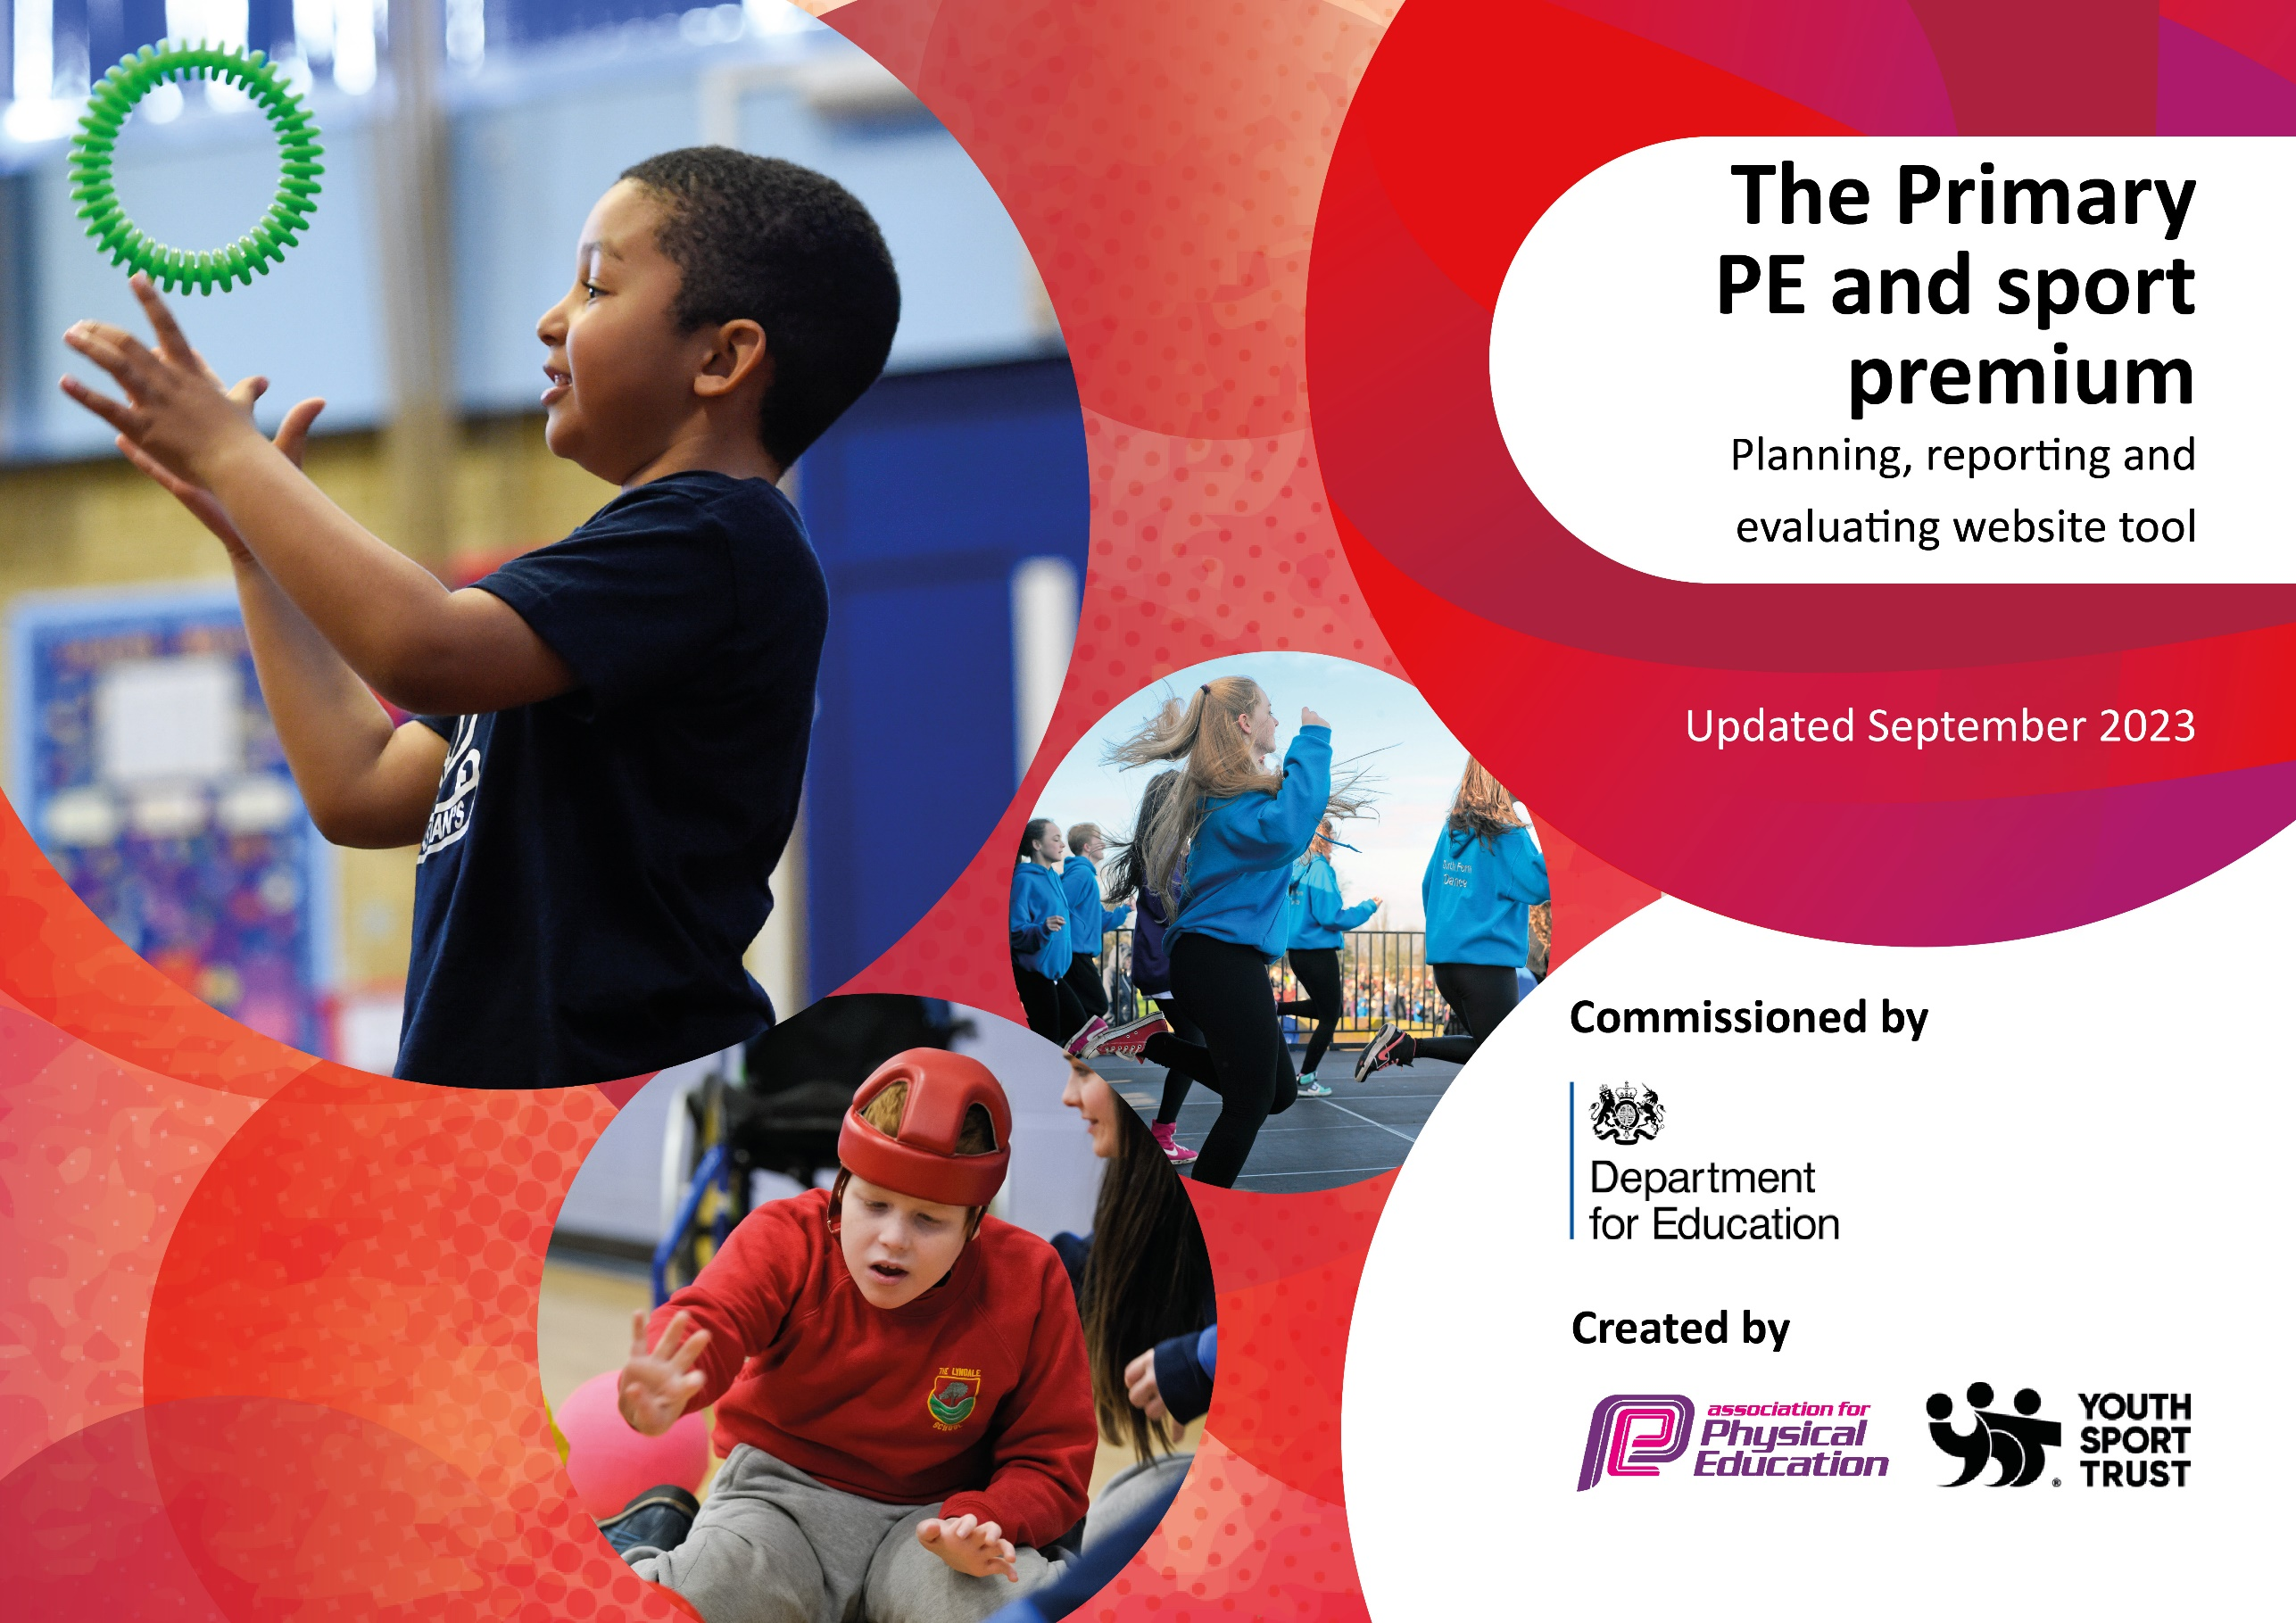

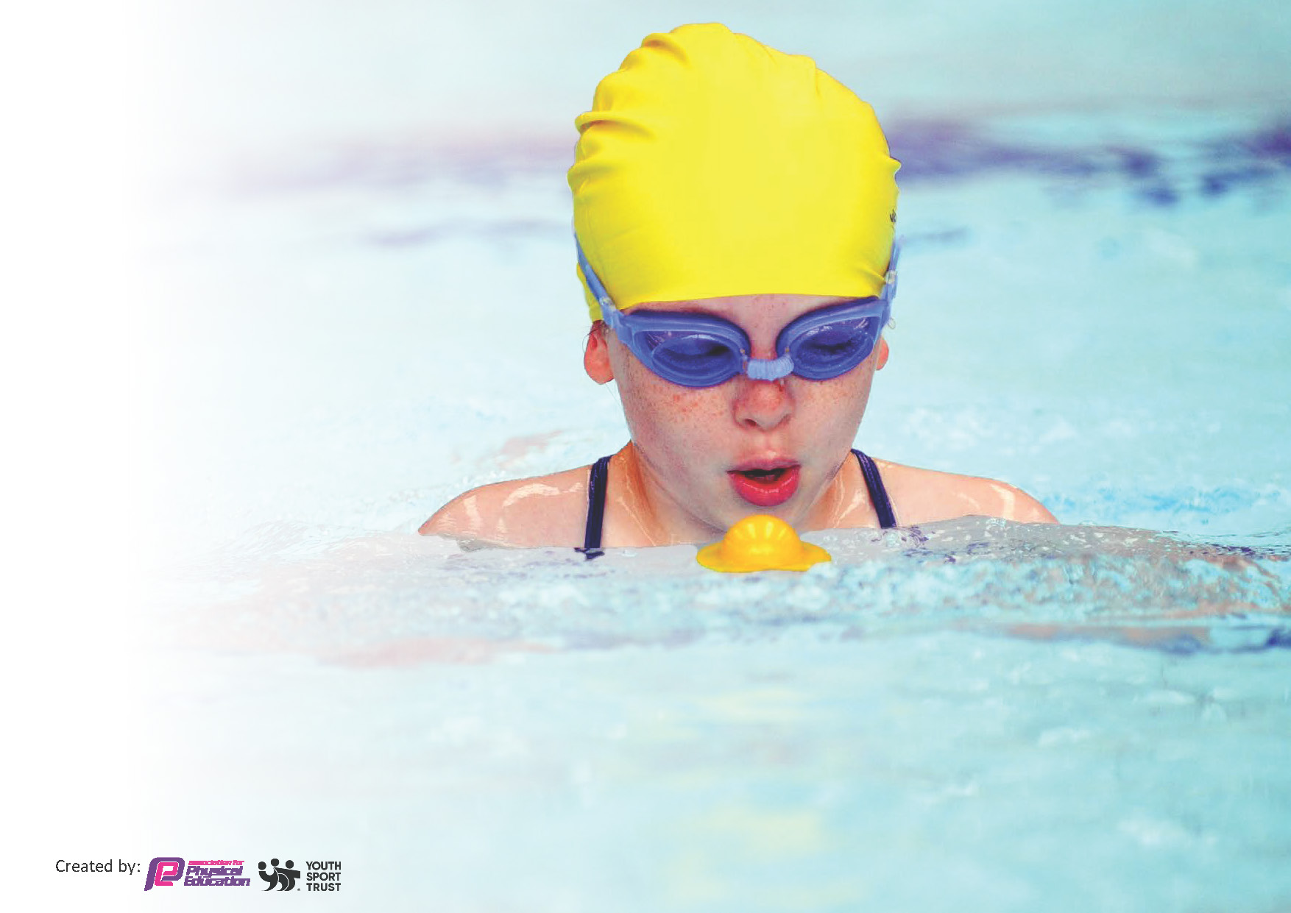
This template can be used for multiple purposes:
by:
- It enables schools to effectively plan their use of the Primary PE and sport premium
- It helps schools to meet the requirements (as set out in guidance) to publish information on their Primary PE and sport premium
- It will be an effective document to support Ofsted inspections enabling schools to evidence progress in Physical Education (PE) and evidence swimming attainment, which forms part of the PE National Curriculum. We would recommend schools consider
the Intent, Implementation and Impact of any spend, as examined within the Education Inspection Framework.

It is important that your grant is used effectively and based on school need.

Schools must use the funding to make additional and sustainable
improvements to the quality of the PE, School Sport and Physical Activity (PESSPA)
they offer. This means that you should use the Primary PE and sport premium to:

- Build capacity and capability within the school to ensure that improvements made now will benefit pupils joining the school in future years
- Develop or add to the PESSPA activities that your school already offers.

The Primary PE and sport premium should not be used to fund capital spend projects; the school’s core budget should fund these. Further detail on capital expenditure can be found in the updated Primary PE and sport premium guidance.

The Primary PE and sport premium guidance, outlines 5 key priorities that funding should be used towards. It is not

necessary that spending has to meet all the key priorities, you should select the priorities that you aim to use any funding towards.

Although completing this template is not a requirement for schools, schools are required to publish details of how they spend this funding. Schools must also outline what the impact this funding has had on pupils’ PE and sport participation and attainment and how any spending will be sustainable in the future. All funding must be spent by 31st July 2024.

The Department for Education has worked closely with the Association for Physical Education (afPE) and the Youth Sport Trust (YST) to develop this template and encourages schools to use it. This template is an effective way of meeting the reporting requirements of the Primary PE and sport premium.
Review of last year’s spend and key achievements (2022/2023)

We recommend you start by reflecting on the impact of current provision and reviewing your previous spend.

Activity/Action | Impact | Comments
There are 5 key indicators that schools should work towards were:  - The engagement of all pupils in regular physical activity.  - The profile of PE and sport is raised across the school as a tool for whole-school improvement.  - Increased confidence, knowledge and skills of all staff in teaching PE and sport, to support sustainable improvements.  - Broader experience of a range of sports and activities offered to all pupils.  - Increased participation in competitive sport. | - See Sports Premium Development Plan 2023 23 for impact and progress against these 5 indicators  - (On our website) | - Ongoing actions have been prioritized in this plan for 2023 24

Key priorities and Planning
This planning template will allow schools to accurately plan their spending.

The Childhood Obesity Plan says that at least 30 minutes of daily activity should take place in schools. All children should have equal access to high-quality PE provision and opportunities to experience and participate in a wide range of sports and physical activities.
Schools should use the PE and sport premium funding to help achieve these aims. They should use it to make additional and sustainable improvements to the PE, sport and physical activity they provide, such as funding high-quality PE and sport for at least 2 hours a week, complemented by a wide range of extracurricular sport and competitive opportunities and providing or improving equal access to sport for boys and girls
Schools should prioritise PE and sport premium spending to improve in the following 5 key areas:
- increasing all staff’s confidence, knowledge and skills in teaching PE and sport
- increasing engagement of all pupils in regular physical activity and sport
- raising the profile of PE and sport across the school, to support whole school improvement
- offer a broader and more equal experience of a range of sports and physical activities to all pupils
- increase participation in competitive sport
Schools can also:
- embed physical activity into the school day by encouraging active travel to and from school and having active break times
- provide targeted activities or support to involve and encourage the least active children
- help to provide equal access for all pupils to the range of sports and physical activities that the school offers
- schools can also use the PE and sport premium to raise attainment in primary school swimming and water safety by funding top-up swimming sessions for those pupils that do not meet national curriculum requirements after they’ve completed core swimming lessons
- schools should consider how the spending will benefit future pupils and what the lasting legacy of this spending will be
- schools should focus their efforts on upskilling the whole staff workforce so that they feel confident and able to lead a PE lesson independently
- schools may wish to engage the expertise of external coaches to offer their pupils a wider variety of sports

Action – what are you planning to do | Who does this action impact? | Key indicator to meet | Impacts and how sustainability will be achieved? | Cost linked to the action
Deliver a vibrant PE curriculum that is resourced and supports all children to progress towards year group and key stage end points. | Staff- delivering and reviewing the curriculum to ensure 2 hours of PE weekly  Pupils- accessing and participating  Parents- ensuring children are in kit and supported to learn basic skills (e.g. through the newsletter)  SLT & PE lead- Monitoring resourcing and PPG/ gender access and participation-  to ensure least active children are engaged | 2  3 | Termly curriculum reviews  Pupil and parent feedback | Balls: £90  Summer term equipment resourcing- TBC  Equipment check: (sport fitness services)  £450
Provide additional sporting events and opportunities for children across the school that encourage participation and celebrate effort and achievement- e.g. swim teams, sport days, borough sports, squad matches, dance events and workshops… | Team-mates squads- ensuring all squad children get chance to represent the school  Children- participating in new opportunities representing the school | 4  5 | Teammate reviews  Pupil and parent feedback  School diary events- spread across the year | Richmond School Sports: £1050  LBRUT Borough Sport costs: £80  Teammates costs (squads and matches tournaments):  Autumn- £5400  Spring- £6900  Summer- TBC  (with parental donations)
Promote positive and healthy messages through a range of activities- residential school journeys, JTAS/ STAs and safe travel (Walk to school week), cycle training, dig day… | Children and families- participating in healthy community behaviours | 2 | School Travel Award  Feedback from trips and residential journeys | JTA Eco conference- one day teacher cover: £220
Provide a lunchtime rota of activities for all children to access as part of their daily schedule- with Green Mile to supplement this. | Children- accessing 30 minutes plus of daily resourced activity  Pupil leaders- enjoying roles (sport leaders/ MHC & Friendship buddies)  Lunch leader team- seeing improved engagement and enjoyment | 4  2 | Pupil voice and leadership  Feedback- shared in assembly  Lunch leader team feedback | Lunchtime resources: £175  Summer- TBA
Improve swimming outcomes (following reduced pool access post CV19).  Introduce badges to assess and motivate pupils.  Encourage all children to participate in our end of year swim gala. | Children- improved engagement and raised attainment  Staff- improved awareness of pupil progress | 2 | Improved end of key stage swimming data and participation in events (gala) | Gala costs- TBC
Subject leader to lead PE across the school- monitoring resourcing and providing CPD as identified. Highlighting leadership priorities via “At a Glance” grid.  Investigating the Sports-mark Award.  Resourcing kit for children to represent the school with pride. | PE lead- leading on school priorities  Colleagues- upskilled for sustainability  Children- accessing a high-quality curriculum | 1 | Curriculum reviews  PE observations and pupil voice  Sports-mark Award progress | PE lead release time (termly)- 3x 0.5 days: £450  External LTA CPD cover: £150  Kit – possible TMs linked sponsorship if required
Arrange for external coaches and speakers to work with and inspire pupils and support professional development across our staff team  e.g. Royal Ballet & Hampton School coaches. | Our staff team- supportive to their CPD  Pupils- working with inspirational visitors | 1  3 | Pupil voice  Curriculum reviews
Offer access to extra-curricular clubs and opportunities for individual pupils- including staff run clubs at a reduced fee. | PPG funded and identified children | 2  4 | Individual pupil feedback and participation  Monitoring of the PPG Grant | PPG fund for individual pupils to access
SPORT PREMIUM FUNDING 2023-24: £19550

Key achievements 2023-2024
This template will be completed at the end of the academic year and will showcase the key achievements schools have made with their Primary PE and sport premium spending.

Activity/Action | Impact | Comments
- AUTUMN REVIEW:
- Resources purchased to enhance curriculum delivery.
- Sport Leaders in role to monitor.
- Ofsted inspection included a positive PE audit.
- Y6 squads in place- training and competitive matches.
- Lunchtime activity rota in place for all children.
- JTA promoting positive sustainable travel messages.
- Hampton school coaching links in place to enhance our curriculum delivery.
- SPRING REVIEW
- As above.
- Y6 squads- all progressed through locality groups to knock out level.
- Netball team at London Youth Games.
- PE lead supporting colleagues through observation.
- Sports day preparations underway (with PTA input).
- Swim sessions booked- contact with pool and parents made.
- Summer term sport club sessions offered to families

Swimming Data 2023 24
Meeting National Curriculum requirements for swimming and water safety.
Priority should always be given to ensuring that pupils can perform safe self-rescue even if they do not fully meet the first two requirements of the National Curriculum programme of study

Question | Stats: | Further context  Relative to local challenges
What percentage of your current Year 6 cohort can swim competently, confidently and proficiently over a distance of at least 25 metres? | %
What percentage of your current Year 6 cohort can use a range of strokes effectively [for example, front crawl, backstroke, and breaststroke]? | %

What percentage of your current Year 6 cohort are able to perform safe self-rescue in different water-based situations? | %
If your schools swimming data is below national expectation, you can choose to use the Primary PE and sport premium to provide additional top-up sessions for those pupils that did not meet National Curriculum  requirements after the completion of core lessons. Have you done this? | Yes/No
Have you provided CPD to improve the knowledge and confidence of staff to be able to teach swimming and water safety? | Yes/No

Signed off by:

Head Teacher: | Alan Went
Subject Leader or the individual responsible for the Primary PE and sport premium: | Jason Richardson
Governor: | A& F Committee
Date:

